PROJECT REPORT

on
Digital Voting Platform

for
Mecatredz
towards partial fulfillment of the requirement
for the award of degree of

Master of Computer Applications
from

Babu Banarasi Das University
Lucknow


Developed and Submitted by Under Guidance of
Ashutosh Pratap Singh Dr. C.K Pandey
1220259010 (Assistant Professor School of Computer
MCA DS & AI Applications, BBD University)
Academic Session 2023 - 24

School of Computer Applications

I Floor, H-Block, BBDU, BBD City, Faizabad Road, Lucknow (U. P.) INDIA 226028
PHONE: HEAD: 0522-3911127, 3911321 Dept. Adm. & Exam Cell: 0522-3911326 Dept. T&P Cell: 0522-3911128; E-Mail: head.sca@gmail.com

www.bbdu.ac.in

CERTIFICATE
This is to certify that Project Report entitled
Digital Voting Platform
being submitted by
Ashutosh Pratap Singh
towards the partial fulfillment of the requirement
for the award of the degree of

Master of Computer Applications
to

Babu Banarasi Das University
Lucknow

in the Academic Year 2023-24

is a record of the student’s own work carried out at Mecatredz and to the best of our knowledge the work reported herein does not form a part of any other thesis or work on the basis of which degree or award was conferred on an earlier occasion to this or any other candidate.
Dr. Prabhash Ch. Pathak

HEAD (School of Computer Applications)

ACKNOWLEDGEMENT

The feeling of acknowledge and expressing it in words are two things apart. It is weakness, but we honestly admit when we truly wish to express our warm gratitude and indebtedness towards somebody, we are always at loss of word.

The project could not have completed without support extends to us by Dr. C.K. Pandey he guided us in preparation of the project and every time when we reached with difficulties, he welcomed them which helped us to successfully complete the project. We express our heartfelt gratitude with great pleasure and a sense of obligation to Dr. C.K. Pandey, our project in charge for her timely support and supervision. And also, we would like to thanks our T&P Co-Ordinator’s for their support and guide.

We would also like to thank Dr. Prabhash Chandra Pathak, our Head of department. He was always there with his support and those wonderful insights whenever eagerly needed.

We would also like to thank Dr. Reena Srivastava Honorable Dean of our Department whose continued cooperation and support top the School of Computer Application was pivotal force in making this project a success.

And, finally a word of gratitude to our family and friends who were always there with their support and encouragement.

DECLARATION

This is to certify that the dissertation entitled Digital Voting Platform is being submitted to the School of Computer Application, Babu Banarasi Das University, BBD City, Faizabad Road, Lucknow Uttar Pradesh - 226 028 India, in partial fulfillment of the requirements for the award of the degree of Master of Computer Applications, is a record of Bonafede work carried out by me under the supervision of Dr. C.K Pandey.

The matter embodied in the dissertation has not been submitted in part or full to any University or Institution for the award of any other degree or diploma.

Student Name: Ashutosh Pratap Singh
University Roll no: 1220259010
School Of Computer Application, Babu Banarasi Das University

TABLE OF CONTENTS
SR No. | Content | Page No.
1. | Introduction of the Project | 1-2
2. | Need of Identification  2.1 Objective | 3
3. | Proposed System | 4
4. | Problem Statement | 5
5. | System Analysis  5.1 System Design  5.1 Feasibility Study  5.3 Modules  5.4 Module Description | 6-12
6. | Software Requirement Specification (SRS)  6.1 Gantt Chart  6.2. Functional Requirement  6.3 Non-Functional Requirement | 13-15
7. | Use Case Diagram | 16
8. | Software Requirement | 17
9. | Hardware Requirement | 18-22
10. | High Level Design | 23
11. | Cost Estimation Model | 24-27
12. | Screen Shots | 28-39
13. | Dynamic Code | 40-52
14. | Futute Scope | 53
15. | Conclusion | 54-55
16. | Bibliography | 56

INTRODUCTION
In an era dominated by technological advancements, traditional democratic processes are undergoing a significant transformation. The integration of blockchain technology into Digital Voting Platforms has emerged as a promising solution to address various challenges encountered in conventional voting systems. This report delves into the innovative fusion of blockchain and voting mechanisms, exploring its potential to enhance the security, transparency, and accessibility of elections worldwide.

The traditional methods of casting votes often face criticism due to issues such as electoral fraud, manipulation, and logistical inefficiencies. These shortcomings have spurred the quest for more robust and trustworthy alternatives, with blockchain technology offering a compelling avenue for reform. By leveraging its immutable ledger and cryptographic algorithms, blockchain introduces unprecedented levels of security and transparency, thereby mitigating many of the vulnerabilities inherent in traditional voting systems.

This report aims to provide a comprehensive analysis of the Digital Voting Platforms empowered by blockchain technology. It will examine the underlying principles of blockchain and its application in the electoral process, highlighting the key features that differentiate blockchain-based voting systems from their conventional counterparts. Furthermore, it will assess the potential benefits and challenges associated with the adoption of such platforms, considering factors such as security, privacy, scalability, and regulatory compliance.

Moreover, this report will explore notable case studies and pilot projects that have implemented blockchain-based voting solutions, offering insights into their real-world implications and outcomes. By examining both successful implementations and existing limitations, this report seeks to provide a nuanced understanding of the opportunities and obstacles inherent in the intersection of blockchain technology and democratic practices.

In conclusion, the integration of blockchain into Digital Voting Platforms represents a paradigm shift in the way elections are conducted, promising to usher in a new era of trust, integrity, and inclusivity in democratic processes. However, it is imperative to critically evaluate the technical, social, and political implications of such innovations to ensure their effectiveness and acceptance on a global scale. Through rigorous analysis and informed discourse, this report aims to contribute to the ongoing dialogue surrounding the evolution of democracy in the digital age.

NEED OF IDENTIFICATION

Security Concerns: Traditional voting systems are susceptible to various security threats, including tampering, hacking, and unauthorized access to sensitive data. Incidents of electoral fraud and manipulation have raised serious doubts about the reliability and accuracy of election results.

Transparency Issues: The lack of transparency in conventional voting mechanisms contributes to public skepticism and distrust in the electoral process. Without a robust system for verifying and auditing votes, allegations of electoral malpractice often go unaddressed, eroding confidence in democratic institutions.

Accessibility Barriers: Physical polling stations present barriers to participation for certain segments of the population, including individuals with disabilities, elderly voters, and those residing in remote or underserved areas. Limited access to polling stations can disenfranchise these groups, undermining the principle of universal suffrage.

Logistical Complexity: Organizing traditional elections entails significant logistical challenges, including the establishment of polling stations, the distribution of ballots, and the coordination of election officials. These logistical hurdles not only increase the cost of elections but also introduce opportunities for errors and delays in the voting process.

Proposed System

Digital Voting System aims to overcome the limitations of traditional paper-based voting systems

Address the challenges associated with Electronic Voting Machines (EVMs)

leveraging blockchain technology and integrating it with the MERN stack (MongoDB, Express.js, React.js, Node.js).

PROBLEM STATEMENT

Security Vulnerabilities: Conventional voting systems are susceptible to various security threats, including tampering, hacking, and manipulation of election results. The lack of robust security measures compromises the integrity of the electoral process and undermines public confidence in the legitimacy of election outcomes.

Transparency Deficits: The opacity inherent in traditional voting mechanisms hampers efforts to verify and audit election results, leading to allegations of electoral malpractice and disenchantment with democratic processes. Without a transparent and accountable system for recording and tallying votes, doubts persist regarding the accuracy and fairness of elections.

Access Barriers: Physical polling stations present barriers to participation for certain segments of the population, including individuals with disabilities, elderly voters, and those residing in remote or underserved areas. The limited accessibility of polling stations restricts the ability of these groups to exercise their right to vote, thereby eroding the principles of equality and inclusivity in democratic governance.

Logistical Complexities: The logistical challenges associated with organizing traditional elections, such as the establishment of polling stations, distribution of paper ballots, and recruitment of election officials, impose significant burdens on electoral authorities and increase the risk of errors and delays in the voting process. These complexities contribute to inefficiencies and inefficacies in the administration of elections, undermining the credibility of electoral outcomes.

ANALYSIS

System Design
The Spiral Model is a Software Development Life Cycle (SDLC) model that provides a systematic and iterative approach to software development. In its diagrammatic representation, looks like a spiral with many loops. The exact number of loops of the spiral is unknown and can vary from project to project. Each loop of the spiral is called a Phase of the software development process.

The exact number of phases needed to develop the product can be varied by the project manager depending upon the project risks.
As the project manager dynamically determines the number of phases, the project manager has an important role in developing a product using the spiral model.
It is based on the idea of a spiral, with each iteration of the spiral representing a complete software development cycle, from requirements gathering and analysis to design, implementation, testing, and maintenance.

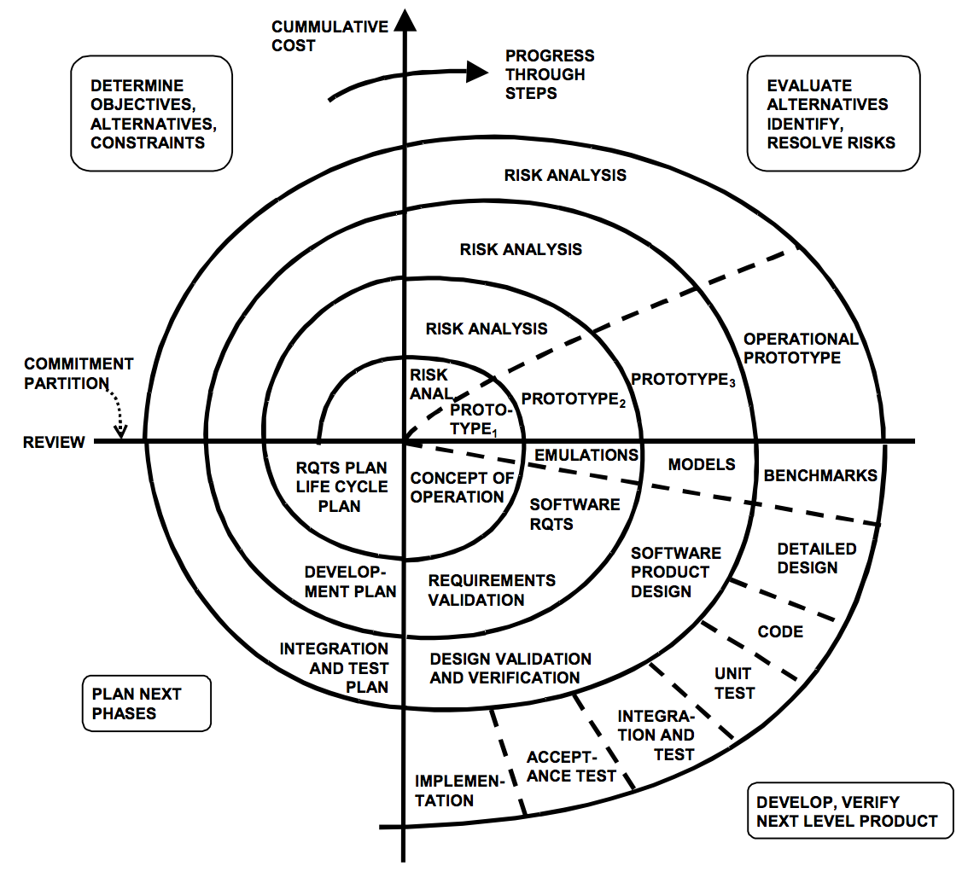
Spiral Model

FEASIBILITY STUDY

1. Technical Feasibility:
Blockchain Infrastructure: Evaluate the technical requirements for implementing a blockchain-based voting platform, including the choice of blockchain protocol (e.g., Ethereum, Hyperledger), consensus mechanism, and smart contract development. Assess the scalability, performance, and interoperability of the chosen blockchain infrastructure to ensure it can support the anticipated volume of transactions during elections.
Security Measures: Analyze the security features of the blockchain network, such as cryptographic encryption, distributed consensus, and permissioned access controls. Assess the robustness of these security measures in safeguarding voter privacy, preventing tampering or manipulation of votes, and protecting against cyber attacks or unauthorized access to the voting system.
Integration with Existing Systems: Consider the integration requirements for interfacing the blockchain-based voting platform with existing electoral infrastructure, voter registration databases, identity verification systems, and ballot distribution channels. Evaluate the compatibility and interoperability of the voting platform with legacy systems to ensure seamless integration and data exchange.

2. Economic Feasibility:
Cost-Benefit Analysis: Estimate the initial capital investment required to develop and deploy the blockchain-based voting platform, including expenses related to software development, infrastructure setup, security audits, and regulatory compliance. Conduct a comprehensive cost-benefit analysis to compare the anticipated benefits of the voting platform (e.g., increased security, reduced administrative costs) against the projected costs over the project lifecycle.
Revenue Generation: Explore potential revenue streams for sustaining the operation and maintenance of the voting platform, such as charging fees for voter registration, ballot casting, or value-added services. Assess the feasibility of generating sufficient revenue to cover ongoing operational expenses and ensure the long-term sustainability of the voting platform without reliance on external funding sources.

3. Legal and Regulatory Feasibility:
Compliance with Electoral Laws: Evaluate the legal and regulatory framework governing elections in the target jurisdiction(s) and assess the compliance requirements for implementing an Digital Voting Platform using blockchain technology. Identify any legal barriers, licensing obligations, or regulatory constraints that may impact the feasibility or legality of the voting platform and develop strategies to address these challenges.
Data Protection and Privacy: Consider the implications of data protection regulations (e.g., GDPR, CCPA) on the collection, processing, and storage of voter information within the blockchain network. Ensure compliance with applicable privacy laws and establish robust data protection measures to safeguard voter confidentiality, prevent unauthorized disclosure of sensitive information, and mitigate the risk of privacy breaches.

4. Operational Feasibility:
User Experience and Accessibility: Assess the usability and accessibility of the blockchain-based voting platform for different user groups, including voters, election administrators, and scrutineers. Conduct usability testing and user feedback surveys to identify any usability issues, accessibility barriers, or technical challenges that may affect the adoption and acceptance of the voting platform.
Training and Support: Develop training materials and provide technical support to election officials, voters, and other stakeholders involved in using the voting platform. Ensure adequate training and support resources are available to familiarize users with the voting process, troubleshoot technical issues, and address any concerns or inquiries during elections.

5. Social and Ethical Feasibility:
Trust and Transparency: Evaluate public perception and trust in the integrity and reliability of the blockchain-based voting platform. Assess stakeholder confidence in the security of the voting system, transparency of the electoral process, and fairness of election outcomes. Address any social or ethical concerns related to the adoption of technology in elections and communicate the benefits of blockchain-based voting in enhancing trust, accountability, and democratic participation.
Inclusivity and Equity: Consider the impact of the voting platform on different demographic groups and marginalized communities, including individuals with disabilities, elderly voters, and those with limited access to technology or internet connectivity. Ensure the voting platform is designed to be inclusive, equitable, and accessible to all eligible voters, regardless of their socio-economic status or technological literacy.

Modules

- Sensor Selection & Placement
- IoT device integration
- Data Transmission
- Centralized Data Storage
- Real-time data processing
- Visualization & Dashboard Creation
- Predictive Analysis
- Remote Monitoring & Control
- Redundancy & Failover Mechanisms
- Integration with Emergency Response System

In this project, two members are involved and so, we have divided the whole project into two groups: -

- Module 1 - Voter Registration

- Module 2 - Ballot creation

- Module 3 – Voting Interface

- Module 4 – Block chain integration

- Module 5 – Result Tabulation

- Module 6 – Audit Trail

The following modules are handled by Ashutosh Pratap Singh: -

- Module 4 - Block chain integration

- Module 5 - Result Tabulation

- Module 6 – Audit Trail

Module Description
- Block chain Integration: By using blockchain technology, each vote is recorded as an immutable transaction on a decentralized ledger, ensuring that votes cannot be tampered with or altered.

- Result Tabulation: The Result Tabulation module in an Digital Voting System is a critical component responsible for the accurate and secure aggregation of votes. This module ensures that all votes cast are correctly counted and tallied in real-time or after the voting period ends.

- Audit Trail: It meticulously logs every action taken within the system, including voter logins, ballot submissions, and administrative changes. By maintaining a detailed and immutable record of all activities, the Audit Trail module facilitates comprehensive tracking and accountability.

SOFTWARE REQUIREMENT SPECIFICATION

Gantt Chart
A Gantt chart is popular type of chart that illustrates a project schedule. Gantt Chart illustrates the start and finish dates of the terminal elements and summary elements of a project. Terminal element and summary comprise the work breakdown structure of the project.

Task | 12Feb-4Mar | 5Mar-14Mar | 15Mar-5Apr | 6Apr-1May | 2May-6May | 7May-12May
Develop project proposal | 22 days
Analysis |  | 10 days
Designing |  |  | 22 days
Coding |  |  |  | 26days
Unit Testing |  |  |  |  | 5 days
Implementation |  |  |  |  |  | 5 days

Functional Requirements

SR. NO | REQ. NO. | PRIORITY | REQUIREMENTS
1. | R1 | R | Open Dashboard
2. | R2 | C | Update Data
3. | R3 | O | Manage Report
4. | R4 | R | Visualize Data
5. | R5 | O | View Dataset
6. | R6 | R | Output Shown on screen

Non-Functional Requirements

CATEGORY | NON-FUNCTIONAL REQUIREMENTS
USABILITY | Users must be able to install the app
RELIABILITY | App permission would be important and will not use any private data of users
PERFORMANCE | They will able to give good perform on most of the OS
SUPPORTABILITY | This software supports all windows above windows 7
IMPLEMENTATION | All users must access the software by opening it in windows device
OPERATION | All the operations performed by user settings in the software
LEGAL | The software should be used as required by local law

Use Case Diagram

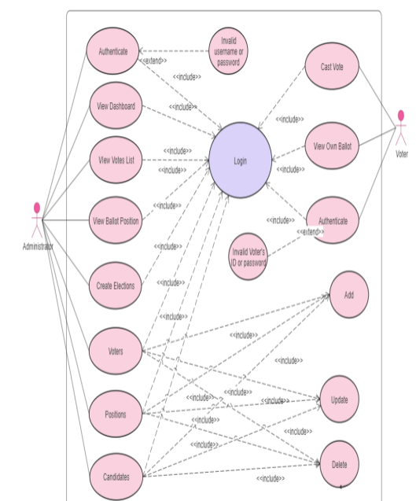

Software Requirement

Client Side
Browser : Chrome 60+ or any browser
Operating System : Any O.S Windows/ Mac/ Linux

Developer Side
Browser : Chrome 60+ or any browers
IDE : VsCode
Operating System : Windows 8 or above
Web Server : Internet Information Server (IIS) 7.0
Documentation Tool : MS Word, MS Power Point
Server Side Language : JavaScript (Node.js, Express.js)

Hardware Requirements

Client Side
Processor | i3 or later
RAM | 2 GB
Disk space | 40 GB
Monitor | 14” or above/ tab/ mobile
Others | Internet Connection

Developer Side

Processor | i3 or later
RAM | 4 GB or above
Disk space | 256 GB
Monitor | 14” or above
Others | Keyboard, mouse, Internet Connection

Mern Stack:
MERN stack stands out for its versatility, efficiency, and end-to-end JavaScript implementation when building web applications. It allows developers to leverage a single language, JavaScript, across the entire stack, enabling code reuse and streamlining the development process. Here is a brief explanation of the stack’s four components:
MongoDB provides a flexible and scalable data management solution.
Express.js simplifies writing code and building back-end components for application development.
React, known for its component-based architecture and efficient rendering, empowers developers to build dynamic and interactive user interfaces.
Node.js enables fast and event-driven back-end development, facilitating seamless communication between the front-end and back-end components.

Overall, MERN stack offers a comprehensive and cohesive framework for building full-stack JavaScript applications. It empowers developers to create modern, responsive, and efficient web experiences. The components work harmoniously, combining their strengths to deliver high-performance applications that can handle complex functionalities.
VS Code
Visual Studio Code is a lightweight but powerful source code editor which runs on your desktop and is available for Windows, macOS and Linux. It comes with built-in support for JavaScript, TypeScript and Node.js and has a rich ecosystem of extensions for other languages and runtimes (such as C++, C#, Java, Python, PHP, Go, .NET).

DESIGN IMPLEMENTATION & CONSTRAINTS

Constraint 1: Minimum 1 GB of hard disk on user is required to setup the software.

Constraint 2: System with proper internet connection is required

Constraint 3: All libraries are required to be installed on user system.

SECURITY REQUIREMENTS

There is only one user of this software or any other normal person with good knowledge of internet and computer.

The analytics or the other person will take the graphical representation and upload it to the software. After tallying the graph with the data set the HYDROEYE software will generate the results.

INTENDED AUDIENCE AND READING SUGGESTIONS

The MULTISITE WEB CRAWLER FOR PRODUCT RECOMMENDATION SYSTEM is intended to be used for everyone who want to plan their learning in proper manner where they can choose various crawler in order to get the most efficient product recommendations.
There is different Audience of this SRS document. Some are-
Developer- Developer uses this SRS for maintainability & modification of this web project. They also use this document to understand the process flow of the system.
Client- Client uses this SRS document to verify the pre-defined requirement. They can also suggest some further requirement in future according as per their need.
Tester- Tester perform black box testing or white box testing according to predefined requisites provided in SRS.
System Analyst- Analyst uses this document for system testing and they use it for analysis of the proposed system as required by client.

PROJECT CATEGORY

The project "Digital Voting Platform Using Blockchain" falls under the category of "Blockchain Applications" or "E-Governance Solutions." It combines elements of blockchain technology with Digital Voting Systems to create a secure and transparent platform for conducting elections or voting processes.

HIGH LEVEL DESIGN

UML Diagram

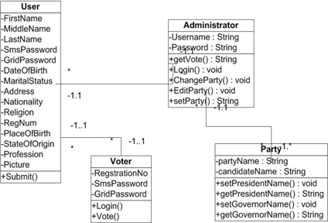

COST ESTIMATION OF PROJECT ALONG WITH COST ESTIMATION MODEL
- Cocomo (Constructive Cost Model) is a regression model based on LOC, i.e. number of Lines of Code. It is a procedural cost estimate model for software projects and is often used as a process of reliably predicting the various parameters associated with making a project such as size, effort, cost, time, and quality. It was proposed by Barry Boehm in 1981 and is based on the study of 63 projects, which makes it one of the best-documented models.
- The key parameters which define the quality of any software products, which are also an outcome of the Cocomo are primarily Effort & Schedule:
- Effort: Amount of labor that will be required to complete a task. It is measured in person-months units.
- Schedule: Simply means the amount of time required for the completion of the job, which is, of course, proportional to the effort put in. It is measured in the units of time such as weeks, months.
- Different models of Cocomo have been proposed to predict the cost estimation at different levels, based on the amount of accuracy and correctness required. All of these models can be applied to a variety of projects, whose characteristics determine the value of constant to be used in subsequent calculations. These characteristics pertaining to different system types are mentioned below.
- Boehm’s definition of organic, semidetached, and embedded systems:
- Organic – A software project is said to be an organic type if the team size required is adequately small, the problem is well understood and has been solved in the past and also the team members have a nominal experience regarding the problem.
- Semi-detached – A software project is said to be a Semi-detached type if the vital characteristics such as team size, experience, knowledge of the various programming environment lie in between that of organic and Embedded. The projects classified as Semi-Detached are comparatively less familiar and difficult to develop compared to the organic ones and require more experience and better guidance and creativity. Eg: Compilers or different Embedded Systems can be considered of Semi-Detached type.
- Embedded – A software project requiring the highest level of complexity, creativity, and experience requirement fall under this category. Such software requires a larger team size than the other two models and also the developers need to be sufficiently experienced and creative to develop such complex models.
- All the above system types utilize different values of the constants used in Effort Calculations.
2. The Intermediate COCOMO
The intermediate model estimates software development effort in terms of size of the program and other related cost drivers parameters (product parameter, hardware parameter, resource parameter, and project parameter) of the project. The estimated effort and scheduled time are given by the relationship:
Effort (E) = a*(KLOC)b *EAF MM
Scheduled Time (D) = c*(E)d Months(M)
Where,
E = Total effort required for the project in Man-Months (MM).
D = Total time required for project development in Months (M).
KLOC = The size of the code for the project in Kilo lines of code.
a, b, c, d = The constant parameters for the software project.
EAF = It is an Effort Adjustment Factor, which is calculated by multiplying the parameter values of different cost driver parameters. For ideal, the value is 1.
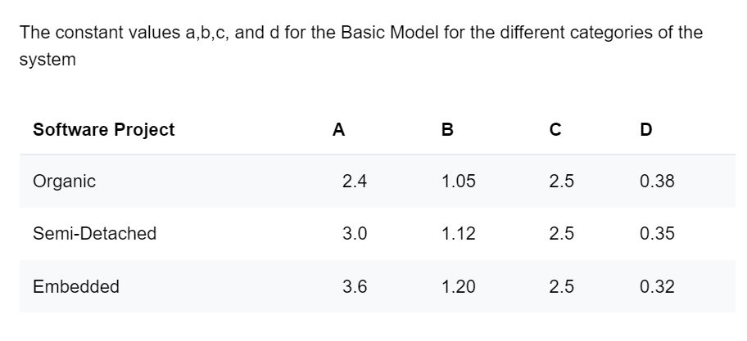
Estimated cost of project:
Project having 1100 line of code
Estimated size of the project =1.1 KLOC
Developer having highly application experience=1.13
Developer having low experience in programming=1.07
Software engineer capacity =1.17
Required Software is normal=1
Size of the database is Normal=1
Size of project is normal=1
Virtual machine environment is normal=1

EAF = 1.13*1.07*1.17*1*1*1*1
EAF=1.414647
Effort (E) = a*(KLOC)b *EAF MM
a =3.0
b =1.12
E=3.0*(1.1) 1.12*1.414647
E=4.72 MM
Scheduled Time (D) = c*(E)d Months(M)
c =2.5
d =0.35
Schedule Time(D)=2.5(4.72)0.35
=4.30

The value for project duration enables the planner to determine a recommended number of people, N, for the project:
N = E/D
N=1.097

SCREENSHOTS OF SOFTWARE


Home Page

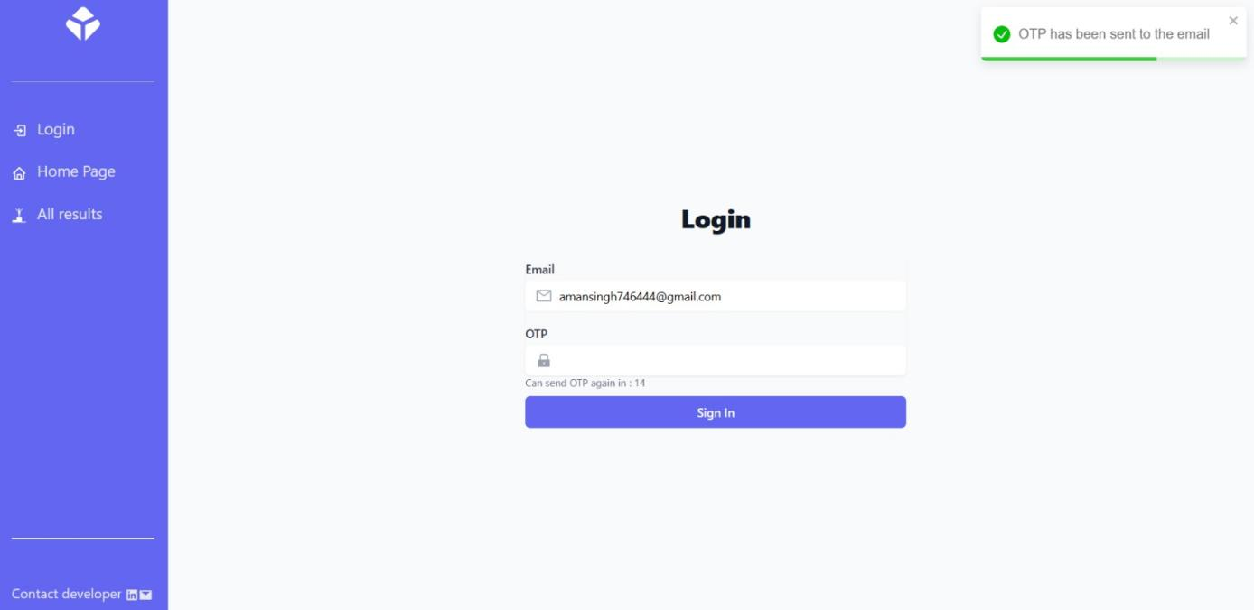

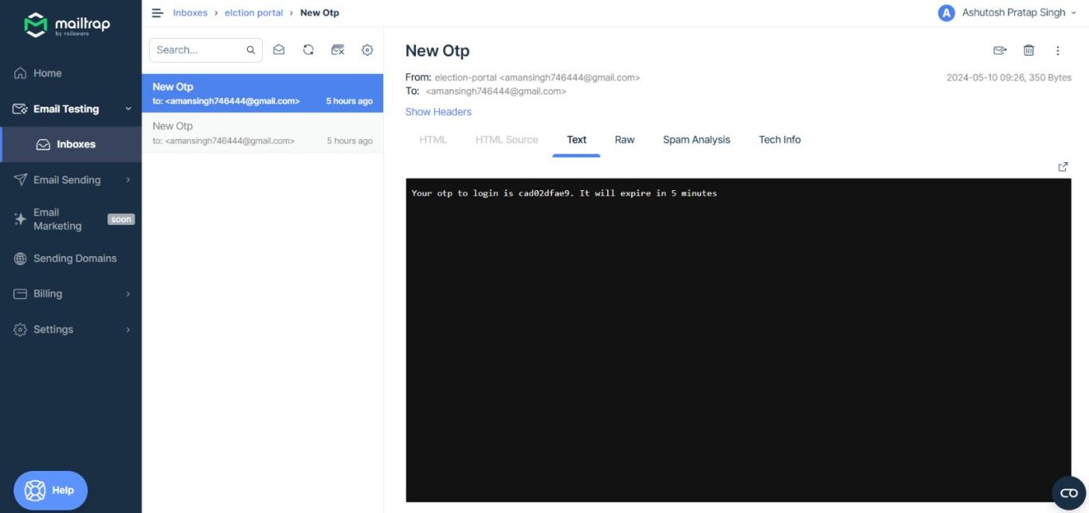

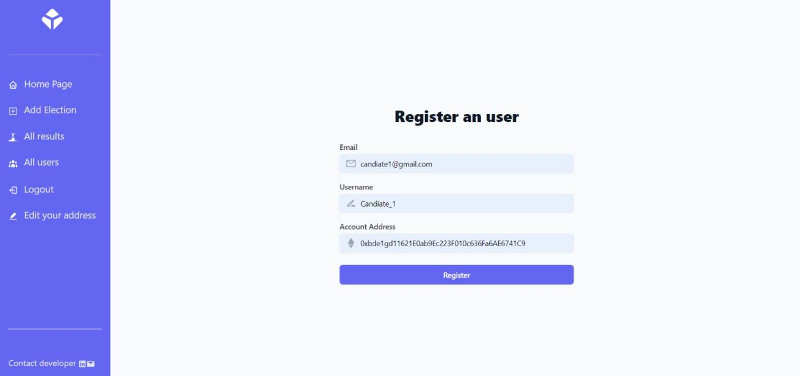

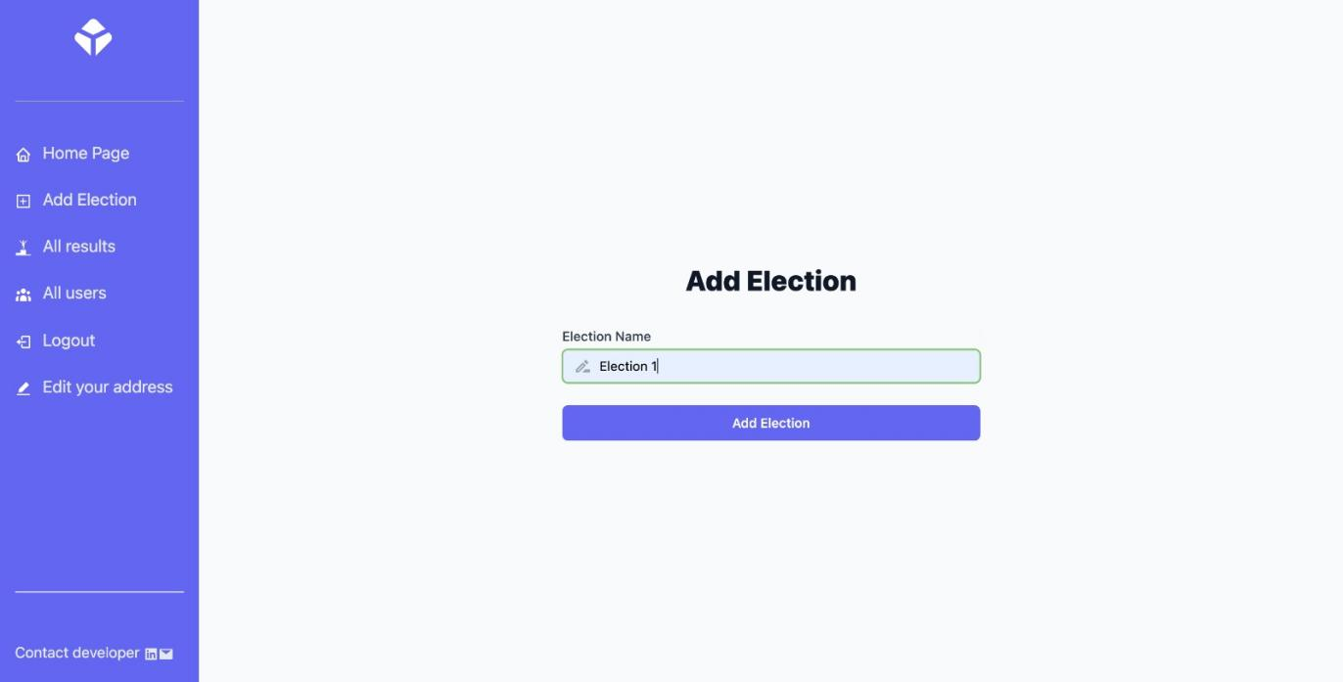

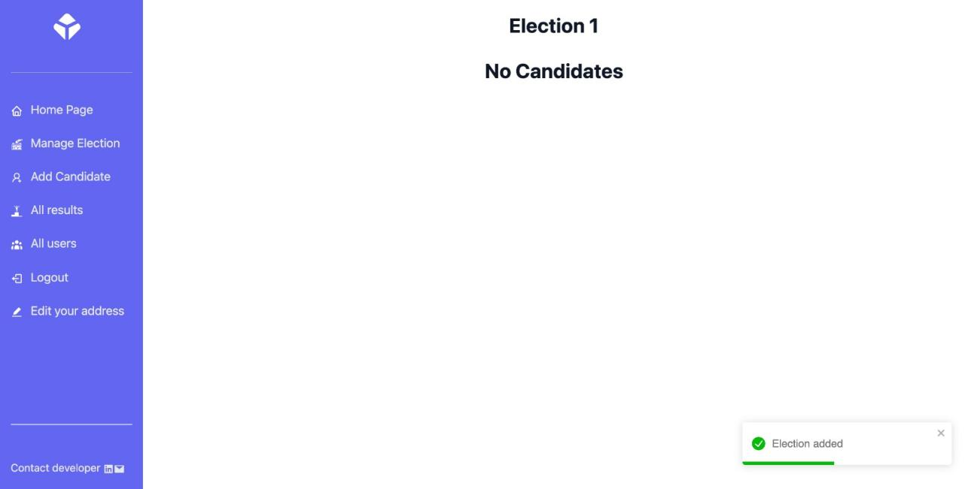

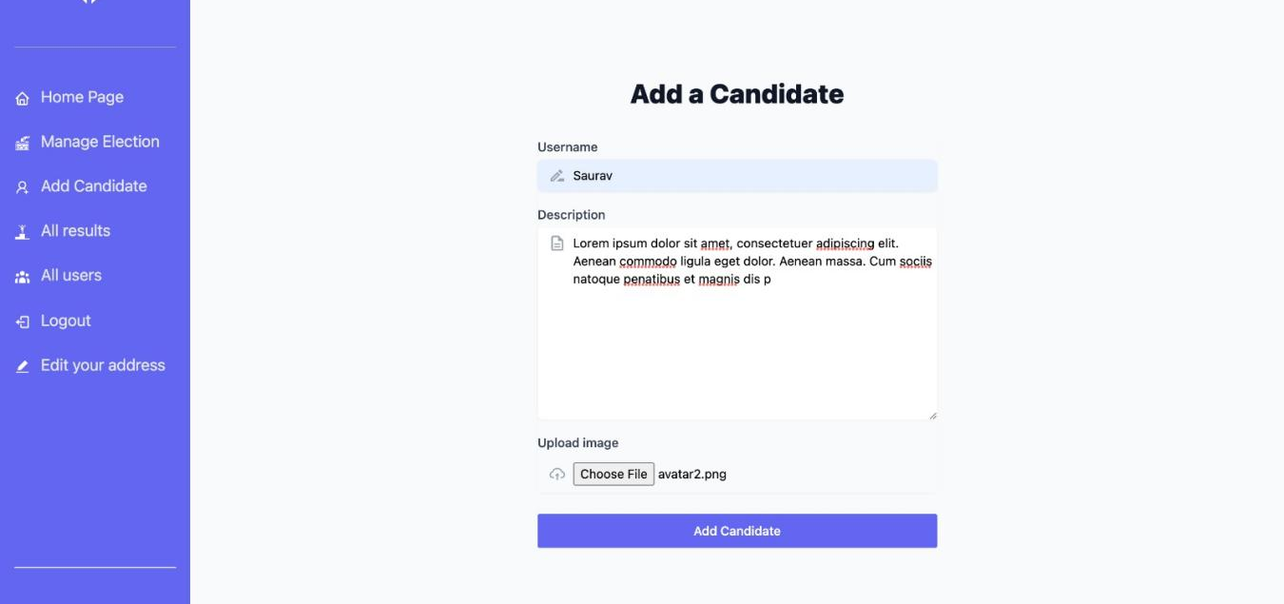

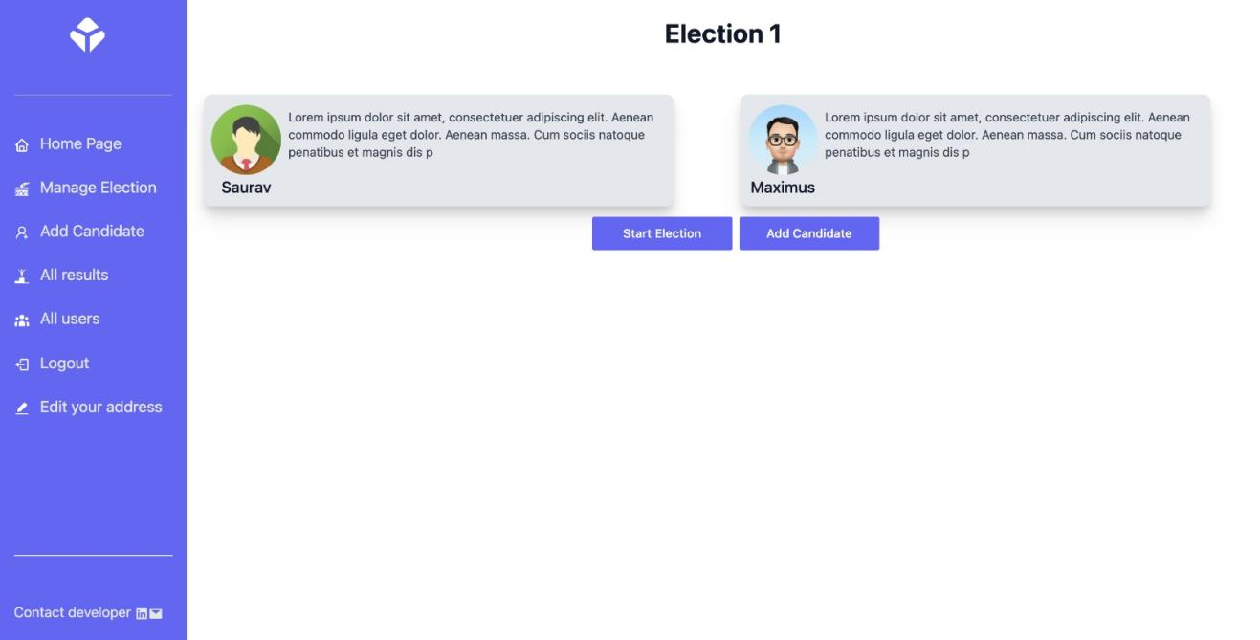

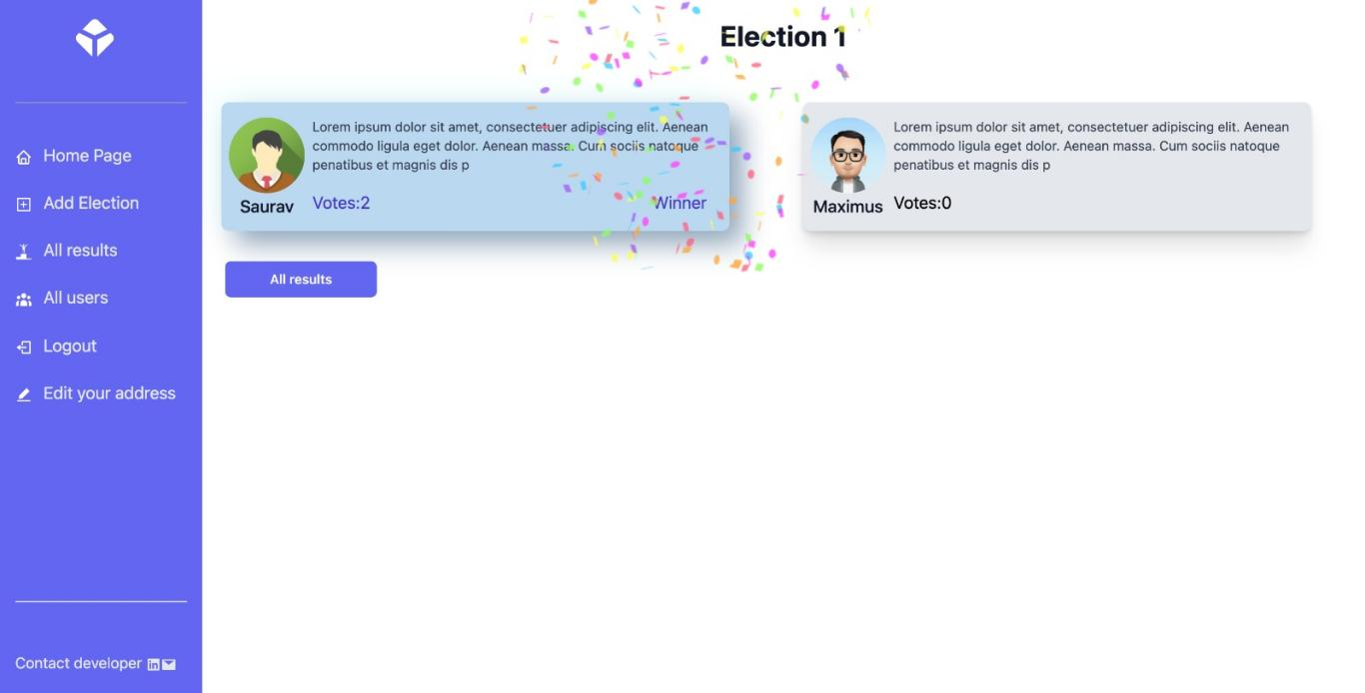

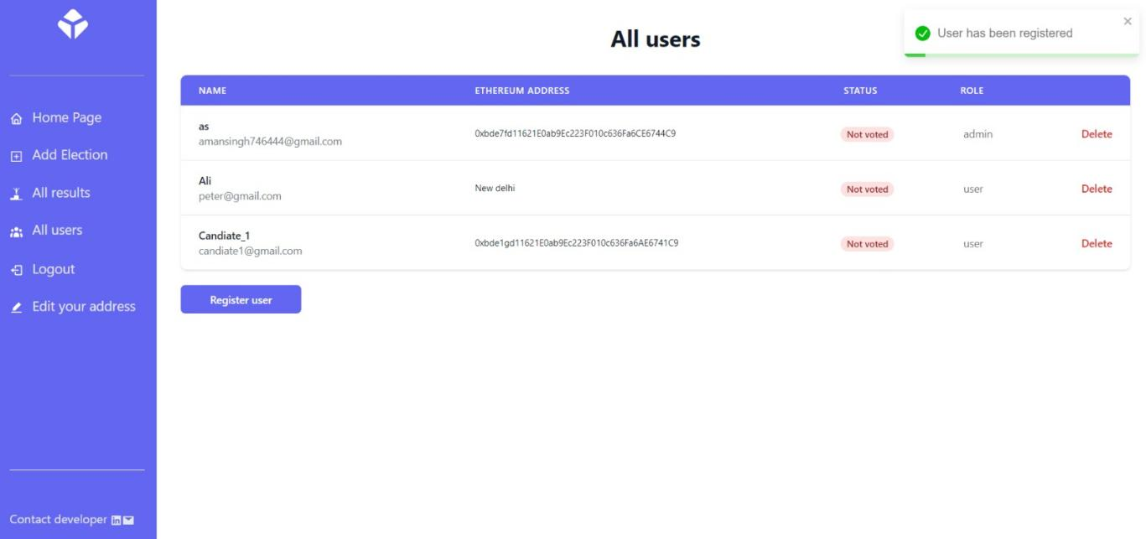

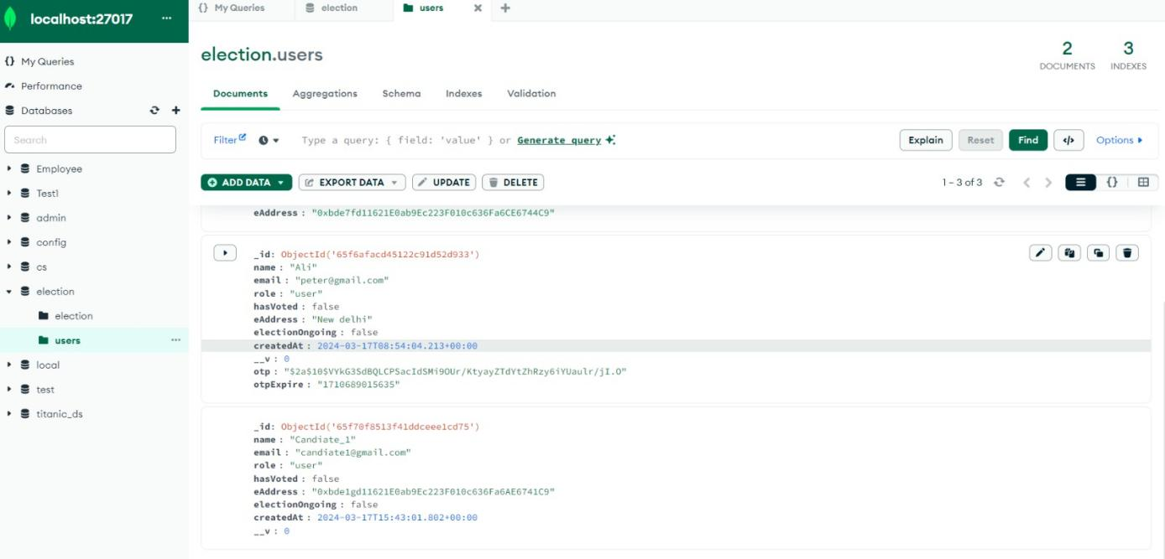

Dynamic Code
exports.registerUser = catchAsyncError(async (req, res, next) => {
console.log(object);
const { name, email, eAddress } = req.body;
if (!email) {
res.status(200).json({
success: false,
message: `no email provided`,
});
}

const user = await User.create({
name,
email,
eAddress,
});
res.status(200).json({
success: true,
user,
});
});

//Acess -> Everyone
//Route -> api/election/getUser
//Description -> Getting one user
exports.getUser = catchAsyncError(async (req, res, next) => {
const user = await User.findById(req.user._id);
res.status(200).json({
success: true,
user,
});
});

//Access -> Everyone
//Route -> /api/election/generateOtp
//Description -> Generating Otp to login
exports.generateOTP = catchAsyncError(async (req, res, next) => {
const { email } = req.body;
if (!email) {
res.status(200).json({
success: false,
message: `no email provided`,
});
}

//Finding user
const user = await User.findOne({ email });
if (!user) {
return next(new ErrorHandler('Invalid Email', 404));
}

//Generating Otp
const otp = user.getOtp();

//saving otp in user
await user.save({ validateBeforeSave: false });

console.log(otp);
//Sending otp email
const message = `Your otp to login is ${otp}. It will expire in 5 minutes`;
try {
if (process.env.NODE_ENV == 'production') {
await sendEmailProd({
to: user.email,
subject: 'New Otp',
html: `<p>${message}</p>`,
});
} else {
await sendEmail({
email: user.email,
subject: 'New Otp',
message,
});
}

res.status(200).json({
success: true,
message: `Email sent to ${user.email}`,
});
} catch (error) {
console.log(error);
user.otp = undefined;
user.otpExpire = undefined;
await user.save({ validateBeforeSave: false });

return next(new ErrorHandler('Internal Server Error', 500));
}
});

//Login a user
//Access -> everyone
// api/election/login
exports.loginUser = catchAsyncError(async (req, res, next) => {
const { email, otp } = req.body;

if (!email || !otp) {
return next(new ErrorHandler('Please enter email and otp'));
}

//finding user in database
const user = await User.findOne({
email,
otpExpire: { $gt: Date.now() },
}).select('+otp');

if (!user) {
return next(new ErrorHandler('Otp is invalid or expired or email id is wrong', 400));
}

//checking otp is correct or not
const isOtpMatched = await user.compareOtp(otp);
if (!isOtpMatched) {
return next(new ErrorHandler('Invalid Email or otp', 401));
}
user.otp = null;
sendToken(user, 200, res);
});

//Logout a user
//Access -> allusers
// api/election/logout
exports.logoutUser = catchAsyncError(async (req, res, next) => {
res.cookie('token', null, {
expires: new Date(Date.now()),
httpOnly: true,
});

res.status(200).json({
success: true,
message: 'Logged out',
});
});

//Get all users
//Access -> admin
// api/election/allUsers
exports.allUsers = catchAsyncError(async (req, res, next) => {
const users = await User.find({});
console.log(users);
// console.log(users,"users");
res.status(200).json({
success: true,
users,
});
});

//Vote a candidate
//Acess -> allusers
// api/election/vote
exports.vote = catchAsyncError(async (req, res, next) => {
const userId = req.user._id;
// console.log(req.user._id);
const newUserData = {
hasVoted: true,
};

const user = await User.findByIdAndUpdate(userId, newUserData, {
new: true,
runValidators: true,
useFindAndModify: false,
});

res.status(200).json({
success: true,
user,
});
});

//Delete a user
//Access -> admin
//api/election/delete/:id
exports.deleteUser = catchAsyncError(async (req, res, next) => {
const user = await User.findById(req.params.id);

if (!user) {
return next(new ErrorHandler(`User not found with id ${req.params.id}`));
}

await user.remove();

res.status(200).json({
success: true,
});
});

//Edit user details
//Access -> user
//api/election/edit
exports.editUser = catchAsyncError(async (req, res, next) => {
const userId = req.user._id;
const { name, eAddress } = req.body;

const newUserData = {
name,
eAddress,
};
const user = await User.findByIdAndUpdate(userId, newUserData, {
new: true,
runValidators: true,
useFindAndModify: false,
});

res.status(200).json({
success: true,
user,
});
});

const AddUser = () => {
const { user, notify } = useContext(AuthContext);
const [loading, setLoading] = useState(false);
const navigate = useNavigate();
const [name, setName] = useState('');
const [email, setEmail] = useState('');
const [eAddress, setEAddress] = useState('');

useEffect(() => {
if (!user) {
notify('You need to login first', 'error');
navigate('/login');
} else {
if (user.role === 'user') {
notify('You do not have access to this route', 'error');
navigate('/');
}
if (user.role === 'admin' && user.electionOngoing) {
notify('You cannot register a user after starting an election');
navigate('/');
}
}
});

import { ethers, upgrades } from "hardhat";
import { Signer } from "ethers";

async function main() {
await deploy();
}

async function deploy() {
try {
console.log("\nInitiating deployment...");
const [deployer]: Signer[] = await ethers.getSigners();
const TokenContract = await ethers.getContractFactory('Election');
const tokenContract: any = await upgrades.deployProxy(
TokenContract,
["MyElection", '0x84dbB98d45c4F001CAC546D65CE2D7C59BC71458'], // Pass both arguments to the constructor
{
initializer: "initialize",
timeout: 0,
}
);
await tokenContract.waitForDeployment();

console.log("Deployment successful");
console.log("\nContract address: ", await tokenContract.getAddress());
} catch (error) {
console.error("\nFailed to deploy");
console.error(error);
}
}

main();

exports.startElection = catchAsyncError(async (req, res, next) => {
const users = await User.find();
users.forEach((user) => {
//sending an email to each user that election has started
electionEmail(user, 'Election has started. Login to vote', next);

//Updating each user ongoing variable to true
updateUser(user, true);
});

res.status(200).json({
success: true,
});
});

//Function to end election
// => api/election/endElection
// admin access
exports.endElection = catchAsyncError(async (req, res, next) => {
let { address } = req.body;

//make election ongoing false in user model
const users = await User.find();
// let isDraw = false;
users.forEach((user) => {
//sending an email to each user that election has ended
electionEmail(
user,
`Election has ended. Visit ${req.protocol}://${req.get('host')}/results/${address}`,
next
);

//Updating each user ongoing variable to false
updateUser(user, false);

//updating each user has voted to false
updateUserVote(user);
});

//sort canddiates

// candidates = sortCandidate(candidates, next);

//checking if there is a draw

// if(candidates[candidates.length - 2].votes == candidates[candidates.length - 1].votes){
// isDraw = true;

// }

//update in datbase

// const newData = {
// isOngoing: false,
// candidates : candidates,
// isDraw: isDraw
// }

// const updatedElection = await Election.findByIdAndUpdate(election.id, newData,{

// new: true,
// runValidators: true,
// useFindAndModify: false
// });

res.status(200).json({
success: true,
});
});

//function to chcnage user onGoing
async function updateUser(user, bool) {
await User.findByIdAndUpdate(
user.id,
{ electionOngoing: bool },
{
new: true,
runValidators: true,
useFindAndModify: false,
}
);
}

axios.defaults.baseURL = process.env.REACT_APP_BE_URL;

function App() {
return (
<BrowserRouter>
<Layout>
<Routes>
<Route path='/' element={<LandingPage />} />
<Route path='/login' element={<Login />} />
<Route path='/register' element={<p>Register user</p>} />
<Route path='/election' element={<Election />} />
<Route path='/results' element={<AllResults />} />
<Route path='/results/:address' element={<SingleResult />} />
<Route path='/users' element={<AllUser />} />
<Route path='/addUser' element={<AddUser />} />
<Route path='/addElection' element={<AddElection />} />
<Route path='/addCandidate' element={<AddCandidate />} />
<Route path='/editUser' element={<EditUser />} />
<Route path='/*' element={<p>Wrong page</p>} />
</Routes>
</Layout>
<ToastContainer />
</BrowserRouter>
);
}

const Election = () => {
const { user, election, notify } = useContext(AuthContext);
const [loading, setLoading] = useState(false);
let tempCandidate;
const navigate = useNavigate();
const [candidates, setCandidates] = useState([]);
const [candidateCount, setCount] = useState(0);
const [electionName, setElectionName] = useState('');

//for validation
useEffect(() => {
(async () => {
if (!user) {
notify('Please login first', 'error');
navigate('/login');
} else {
//get intial value of validAccount, if the user is using right ethereum ot not
//getAccount();
//checking if there is no ongoing election
if (election === '0x0000000000000000000000000000000000000000') {
navigate('/');
}
//election.ongoing is only true if admin adds an election
if (user.electionOngoing === false && user.role !== 'admin') {
notify('There is no ongoing election', 'error');
navigate('/');
}
}
})();
});
//to get all candidates
useEffect(() => {
let b = async () => {
//try{
setLoading(true);
if (election !== '0x0000000000000000000000000000000000000000') {
const Election = Electioneth(election);
//getting candidate count
let count = await Election.methods.candidateCount().call();
setCount(+count);

//getting election name
let name = await Election.methods.electionName().call();
setElectionName(name);

//getting all candidates and storing in one variable

tempCandidate = await Promise.all(
Array(+count)
.fill(1)
.map((element, index) => {
return Election.methods.candidates(index).call();
})
);
setCandidates(tempCandidate);
//console.log(tempCandidate);
}
setLoading(false);
};
b();
return () => {
b = null;
};
}, []);

// //use effect to remove bug where user rejects second transaction while ending election
useEndElection('election', setLoading);

return (
<>
{!loading && candidateCount >= 0 && (
<h2 className='mt-5 text-center text-3xl font-bold mb-8 text-gray-900'>
{electionName}
</h2>
)}
{!loading && candidateCount === 0 && (
<h2 className='mt-5 text-center text-3xl font-bold mb-8 text-gray-900'>
No Candidates
</h2>
)}
{!loading &&
election !== '0x0000000000000000000000000000000000000000' &&
candidateCount > 0 && (
<>
{/* <th>Vote</th> */}
<div className=''>
<div className='grid lg:grid-cols-2 md:grid-cols-2 sm:grid-cols-1 '>
{candidateCount &&
candidates.map((candidate, index) => (
<ShowCandidate
key={index}
id={index}
candidate={candidate}
candidateCount={candidateCount}
setLoading={setLoading}
/>
))}
</div>
<div className='flex mt-3 relative justify-center'>
{user && !user.electionOngoing && user.role === 'admin' && (
<>
<StartElection setLoading={setLoading} />

<Link to='/addCandidate '>
<button className='lg:w-40 md:w-30 ml-2 flex justify-center py-2 px-4 border border-transparent text-sm font-medium rounded-sm text-white bg-indigo-500 hover:bg-indigo-600 focus:outline-none focus:ring-2 focus:ring-offset-2 focus:ring-indigo-400'>
Add Candidate
</button>
</Link>
</>
)}
</div>
<div className='flex justify-end lg:px-24 md:px-8 px-4 '>
{user && user.electionOngoing && user.role === 'admin' && (
<button className='w-40 ml-6 flex justify-center py-2 px-4 border border-transparent text-sm font-medium rounded-sm text-white bg-indigo-500 hover:bg-indigo-600 focus:outline-none focus:ring-2 focus:ring-offset-2 focus:ring-indigo-400'>
<EndElection setLoading={setLoading} />
</button>
)}
</div>
</div>
</>
)}
{loading && <Loading />}
</>
);

FUTURE SCOPE

In the future, the Digital Voting System could be further enhanced with additional features such as biometric authentication, multi-factor verification, and integration with emerging technologies like artificial intelligence (AI) and Internet of Things (IoT) devices.
Furthermore, the system could be scaled to support larger elections, including national and international voting events, while also addressing challenges such as scalability, security, and regulatory compliance.
Continuous research and development are essential to ensure the ongoing improvement and adoption of digital voting infrastructure globally.
An electronic hardware device can be used as a input device in this voting platform and provide more user friendly interface.
Biometric sensors can also be used to provide more secure environment for conducting the election preventing invalid votes.

CONCLUSION

- The implementation of an Digital Voting Platform leveraging blockchain technology represents a significant milestone in the quest to modernize and secure democratic processes. Throughout this project, we have explored the transformative potential of blockchain in revolutionizing the way elections are conducted, with a focus on enhancing security, transparency, and accessibility.

- Blockchain technology offers a compelling solution to address the inherent challenges of traditional voting systems, including security vulnerabilities, transparency deficits, and access barriers. By leveraging its decentralized architecture, cryptographic security, and immutable ledger, blockchain empowers Digital Voting Platforms to safeguard voter privacy, prevent tampering or manipulation of votes, and enable real-time verification and auditability of election results.

- Moreover, blockchain-based voting platforms have the potential to overcome geographical barriers and promote inclusivity by enabling broader participation in elections, particularly among marginalized communities and underserved populations. By providing a secure and accessible means for citizens to exercise their democratic rights, these platforms foster greater civic engagement, strengthen democratic institutions, and uphold the principles of equality and representation.

- However, the successful implementation of blockchain-powered Digital Voting Platforms requires careful consideration of technical, economic, legal, operational, and social factors. It entails the development of robust security measures to protect against cyber threats, compliance with regulatory requirements to ensure legal validity, and engagement with stakeholders to build trust and confidence in the electoral process.

- As we conclude this project, it is evident that blockchain technology holds immense promise in securing democracy and advancing the principles of transparency, accountability, and inclusivity in electoral governance. By continuing to innovate and collaborate across interdisciplinary domains, we can harness the full potential of blockchain to shape the future of democracy and empower citizens to participate meaningfully in the decision-making process.

- In closing, let us embrace the transformative power of blockchain and Digital Voting Platforms as catalysts for positive change, driving us towards a more resilient, equitable, and participatory democracy for generations to come.

BIBLIOGRAPHY

Urls:-
https://www.mongodb.com/docs/v6.3/query-api/

https://devdocs.io/react/react-component#componentdidcatch

https://nodejs.org/docs/latest/api/

https://expressjs.com/en/guide/routing.html

https://blockchain.gov.in/Home/BlockChain?blockchain=blockchain#:~:text=Blockchain%20is%20a%20shared%20immutable,shared%20over%20a%20computer%20network.

https://www.ibm.com/topics/smart-contracts

https://www.youtube.com/watch?v=ZJ9alighYrY

https://tatum.io/blog/simplify-metamask-integration#:~:text=We%20can%20say%20undoubtedly%20that,our%20Vanilla%20JS%20guide%20here.

